**Lab Tasks**

**By**

**Alishba Waqar(46997)**

**Submitted to**: Ma’am Kausar

**Subject**: Operating System

**Date**:10/8/2024

**BSCS SEMESTER – 5**

**RIPHAH INTERNATIONAL UNIVERSITY**

**ISLAMABAD, PAKISTAN**

**Task**

1. **Write a C/C++ program that uses the fork() function and the logical AND (&&) operator.**

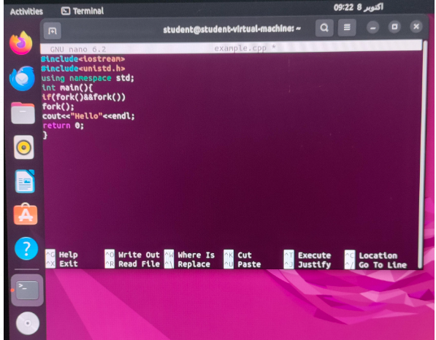

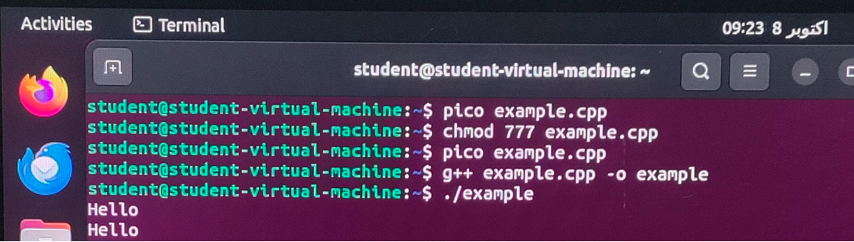

In AND operator if both conditions are true then it will proceed same in this program fork means create child. First fork creates child (0) and parent (1). The second fork is called for Parent (1) child (0) will be terminated. Then the parent (1) will be divided into Child (0) and Parent (1). Again, last fork is only called for parent (1+1 = true) Child is terminated. Parent is divided into Child (0) and Parent (1). In this way it will give in output 2 hello.

1. **Write a C/C++ program that uses the fork() function and the logical OR (II) operator.**

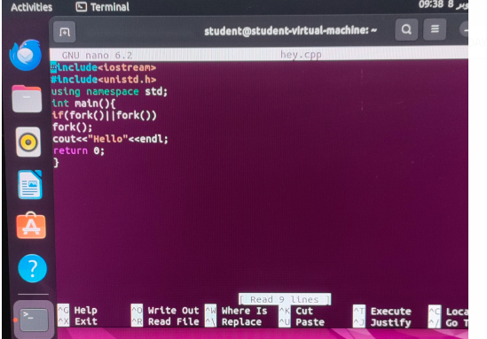

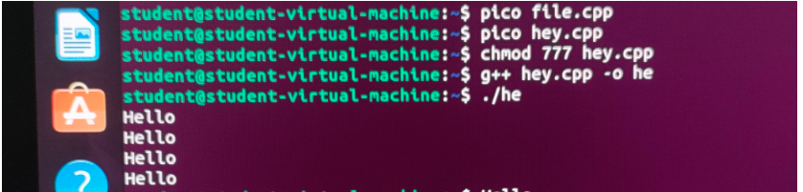

In OR operator if any of one is true, the result will be true then it will proceed same in this program fork means create child. First fork creates child (0) and parent (1). The second fork is called for both Parent (1) child (1). Then the parent (1) will be divided into Child (0) and Parent (1) and Child (1) will be divided into Child (0), Child (0). One condition in child (1) is true (0+1=true). It will further divide into Child (0) and Child (0) this is the last call of fork. In this way 4 times hello is printed.

1. **Write a C++ program that uses fork() to create a child process. Use an if-else statement.**

In this program we have used AND operator with if else case means if case fork fails then else case will run. AND the operator will work if one of the conditions is false it will false.